

s

TASCOMP

**Software Design Document**

ReportPro – Configuration Program

|  |  |
| --- | --- |
|  |  |
|  |  |
| Reference: | SDD-TA-250429.0 |
| Revision: | 0 |
| Revision Date: | 29th April 2025 |
| Revision Author: | Tom Atkinson |

**Revision History**

|  |  |  |  |  |
| --- | --- | --- | --- | --- |
| **Revision** | **Revision Date** | **Revision Author** | **Reviewed by** | **Review Date** |
| 0 | 29th Apr 2025 | Tom Atkinson | Alan Williamson | 13th May 2025 |
| **Description** | | | | |
| Initial version of document created | | | | |

**Contents**

1. Introduction 4

2. Report Configuration 5

3. UI Design 6

# Introduction

During the development of ReportPro it was intended to have a configuration program to configure an automatic report. This design document will cover this program. It should be fairly simplistic with just some simple logic for managing/updating an associated expr file.

At the time of writing the configuration is currently managed through manually updating an Excel spreadsheet which has issues with invalid inputting of values and was only intended as a simple temporary option.

# Report Configuration

A report configuration program will be made for users to define what the resulting data analysis is like. Specifically it will include the following:

* Output location details (email, file directory, etc.)
* Time range to cover in report
* Desired pages/metrics in report
* Limits of low/high values for data
* Output locations (SQL/Excel)
* Company info

This will be a fairly simplistic Windows Forms project made using C++/CLI.

The user will be able to have multiple configurations for multiple different output report styles and structures that can be easily switched between.

Once updated the user will be able to click an “Apply” button. This will update the expr configuration file associated with ReportPro. The expr file can then be read in by the R code.

# UI Design

Below is a wireframe design with all the possible editable fields for a ReportPro report.

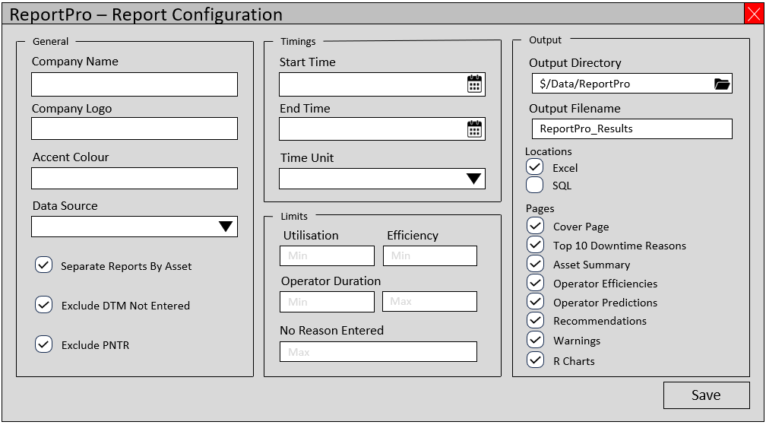

The idea for this configuration form is that it will validate all inputted values to ensure that a report can be created using the inputted data values.